Predicting stuff in electrochemical cells. Teacher Handout.

- Work out what the two half equations involve in the two cells. Show as REDUCTION, like in the Eº Table.
- Note this under the cells.
- Look to the Eº Table and copy the Eº value.
- Now work out where oxidation (OIL) and reduction (RIG) occur.
- Show movement of electrons across the external wire.
- Show movement of ions in the salt bridge.
- Work out the Eº Nett for standard conditions.

Example. For a Cu/Cu²⁺_{(aq)} // Ni/Ni²⁺_{(aq)} electrochemical cell.

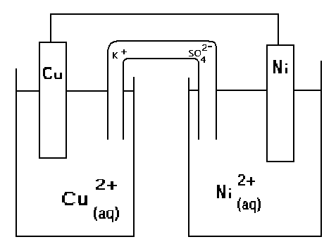
1&2. Cu²⁺ + 2e⁻ → Cu Ni²⁺ + 2e⁻ → Ni
- Cu²⁺ + 2e⁻ → Cu +0.34 Ni²⁺ + 2e⁻ → Ni -0.26
- (Change the Ni ½ eqn)
Cu²⁺ + 2e⁻ → Cu +0.34 Ni → Ni²⁺ + 2e⁻ +0.26
(RIG) Reduction (OIL) Oxidation
5.
Here Nickel is giving up electrons so electrons move FROM the Ni metal.

6.To complete the closed circuit SO₄²⁻ moves Right, K⁺ moves LEFT.
7. Eº nett = 0.34 +0.26 = 0.60 Volts

Predicting stuff in electrochemical cells. WORKSHEETS. Wilfred’s Woblies.

For each of the following pairs of half cells

- Work out what the two half equations involve in the two cells. Show as REDUCTION, like in the Eº Table.
2. Note this under the cells.
3. Look to the Eº Table and copy the Eº value.
4. Now work out where oxidation (OIL) and reduction (RIG) occur.
5. Show movement of electrons across the external wire.
6. Show movement of ions in the salt bridge.

1. Silver –Tin.

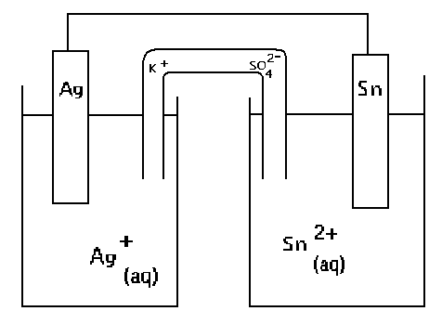

2. Chromium - Lead

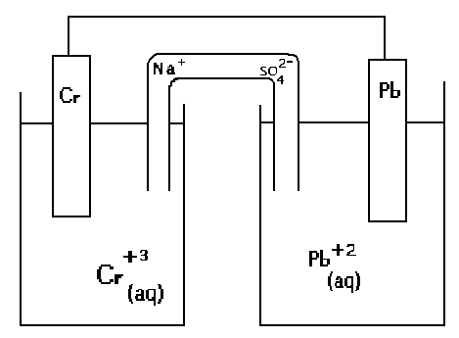

- Mercury – Hydrogen with Platinum electrodes.

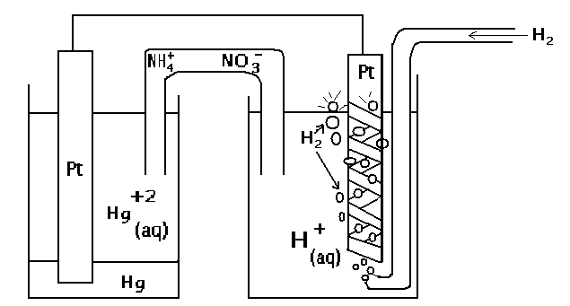

- Oxygen in acid solution (Pt electrode) – Cadmium

